 | SR UNIVERSITY  Campus Warangal
 | Program: II - B. Tech (CS& AI) Batch:
 | Name: CH.SINDHUJA Reg. No: 2503A52430
 | Department: Computer Science and AI Semester: I
 | AAssisted Coding-Assignment Date: 22-09-2-2026

Question 1:
Q1 – AI-Assisted Bubble Sort Analysis
Problem / Starter Code:
numbers = [64, 34, 25, 12, 22, 11, 90]
TODO:
Implement Bubble Sort in ascending order.
Count comparisons and swaps.
Display the sorted list.
Student Tasks:
• Implement Bubble Sort.
• Use AI to explain one complete pass of Bubble Sort.
• Count comparisons and swaps.
• Test at least three input lists.
• Ask AI about an early-exit optimisation.
• Compare the original and improved versions.

2.PROMPT:

“Explain Bubble Sort step by step for this list. Show one complete pass, count comparisons and swaps, and explain how early exit can make it faster. Don’t write the full code.”

3.CODE:

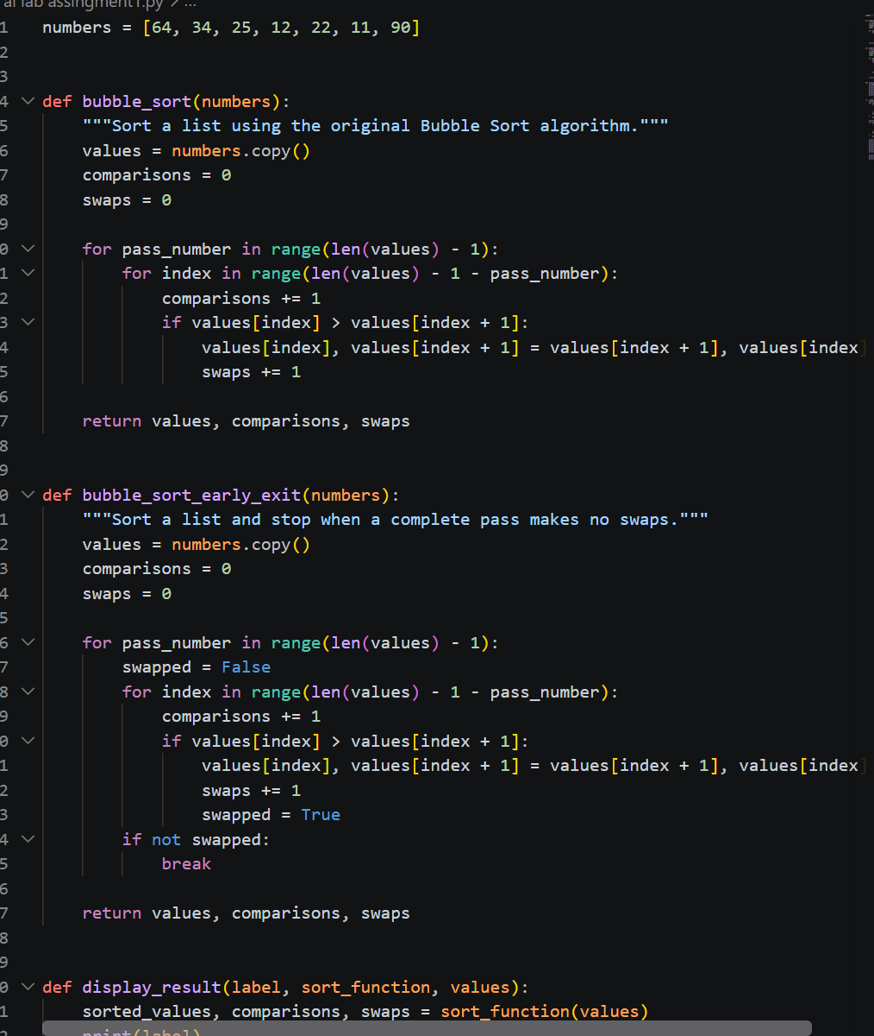

4.OUTPUT:
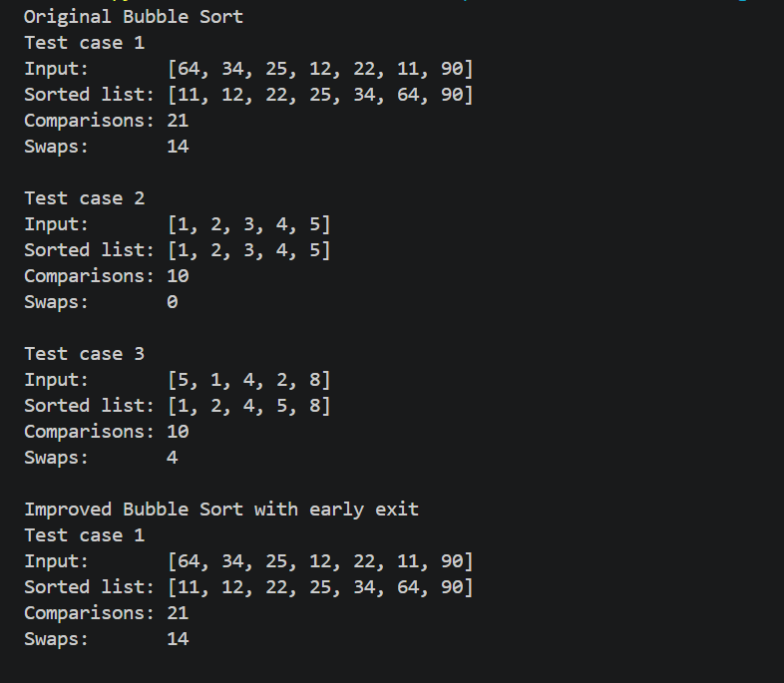

5.OBSERVATION:
Bubble sort compares adjacent elements and swaps them.
The list is sorted in ascending order
Each pass moves the largest element to the end
Comparisons and swaps depend on the input lists

Question 2:
Q2 – Linear Search vs Binary Search
Problem / Starter Code:
numbers = [5, 12, 18, 23, 31, 45, 56, 72, 89]
target = 45

TODO:
Implement Linear Search.
Implement Binary Search.
Compare the number of comparisons.
Student Tasks:
• Implement Linear Search and Binary Search.
• Use AI to explain why Binary Search requires sorted data.
• Count comparisons for both algorithms.
• Test first, middle, last and absent elements.
• Compare the results and explain suitable use cases.
• Use AI to suggest a valid optimisation.

2.PROMPT: Write a Python assignment question titled "Q2 – Linear Search vs Binary Search". Use the data: `numbers = [5, 12, 18, 23, 31, 45, 56, 72, 89]` and `target = 45`. Have students implement both algorithms, count the comparisons, and provide a full Python solution.

3.CODE:
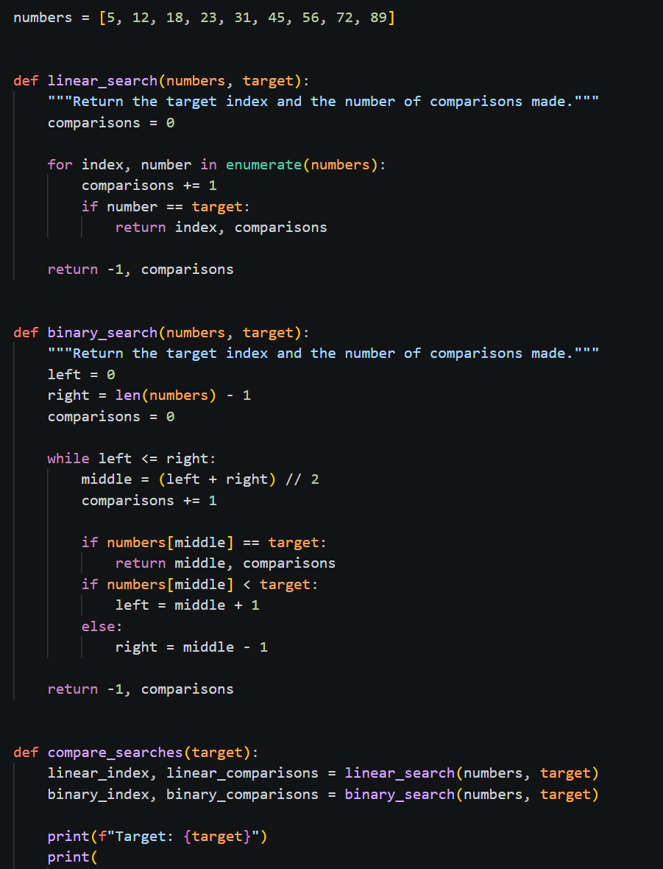
4.OUTPUT:
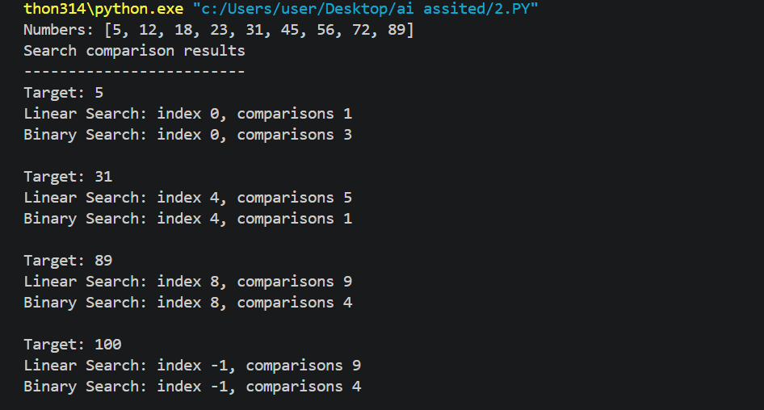

5.OBSERVATION:
* Linear Search checks elements one by one and works on sorted or unsorted data.
* Binary Search is faster but requires the list to be sorted.
* Binary Search uses fewer comparisons for large datasets.
* For small or unsorted lists, Linear Search is simple and suitable.

Question 3:
Q3 – Compare Sorting Algorithms
Problem / Starter Code:
data = [45, 12, 78, 34, 23, 89, 5, 67, 10, 56]

TODO:
Sort using Bubble Sort, Selection Sort and Insertion Sort.
Compare their performance.
Student Tasks:
• Implement all three sorting algorithms.
• Use the same input for each algorithm.
• Count comparisons and swaps/shifts.
• Use AI to explain strengths and weaknesses.
• Ask AI which algorithm suits nearly sorted data.
• Compare experimental results with theoretical complexity.

2.PROMPT:
Implement Bubble Sort, Selection Sort, and Insertion Sort for the given data, count comparisons and swaps/shifts, compare their strengths, weaknesses, time complexities, and identify which algorithm is best for nearly sorted data.

3.CODE:

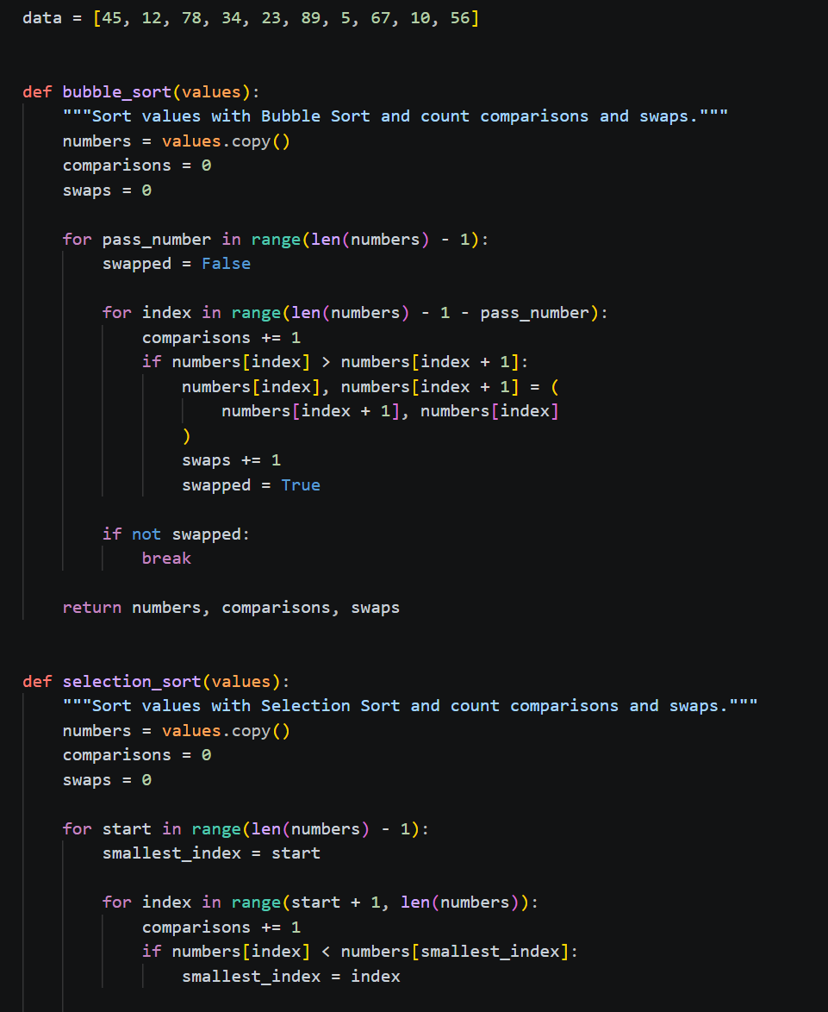
4.OUTPUT:
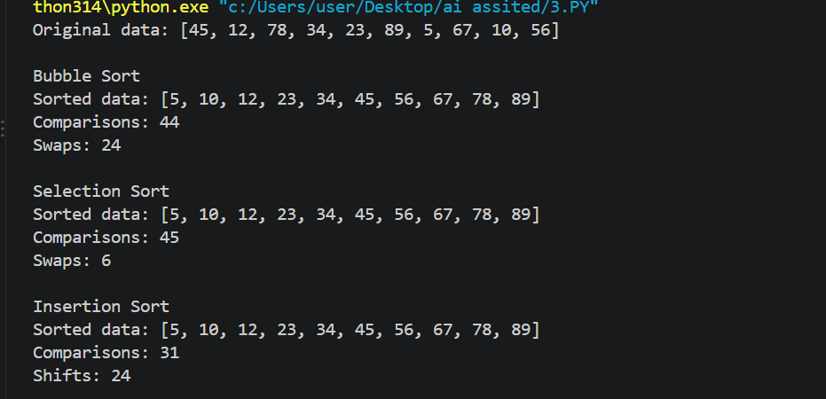

5.OBSERVATION:
* All three algorithms correctly sort the same input data in ascending order.
* Bubble Sort and Selection Sort generally require more comparisons.
* Insertion Sort performs well when the data is nearly sorted.
* All three have *O(n²)* average/worst-case time complexity.
* The practical performance depends on the input order and number of swaps/shifts.

Question 4:
Q4 – Optimising a Student Search and Sort Program

Problem / Starter Code:
students = [
("Arun", 82

("Bala", 65),
("Chitra", 91),
("Divya", 74),
("Esha", 88)
]

TODO:
Find the highest mark.
Sort students by mark.
Search for a student by name.
Improve the solution using AI.
Student Tasks:
• Write functions for highest mark, sorting and name search.
• Create a straightforward solution first.
• Use AI to identify unnecessary operations.
• Ask AI for a more efficient approach.
• Implement only suggestions you understand.
• Compare original and improved time complexity.

2.PROMPT:
Write a simple Python program to find the highest mark, sort students by marks, and search for a student by name. Then suggest a more efficient approach and explain the time complexity.”

3.CODE:
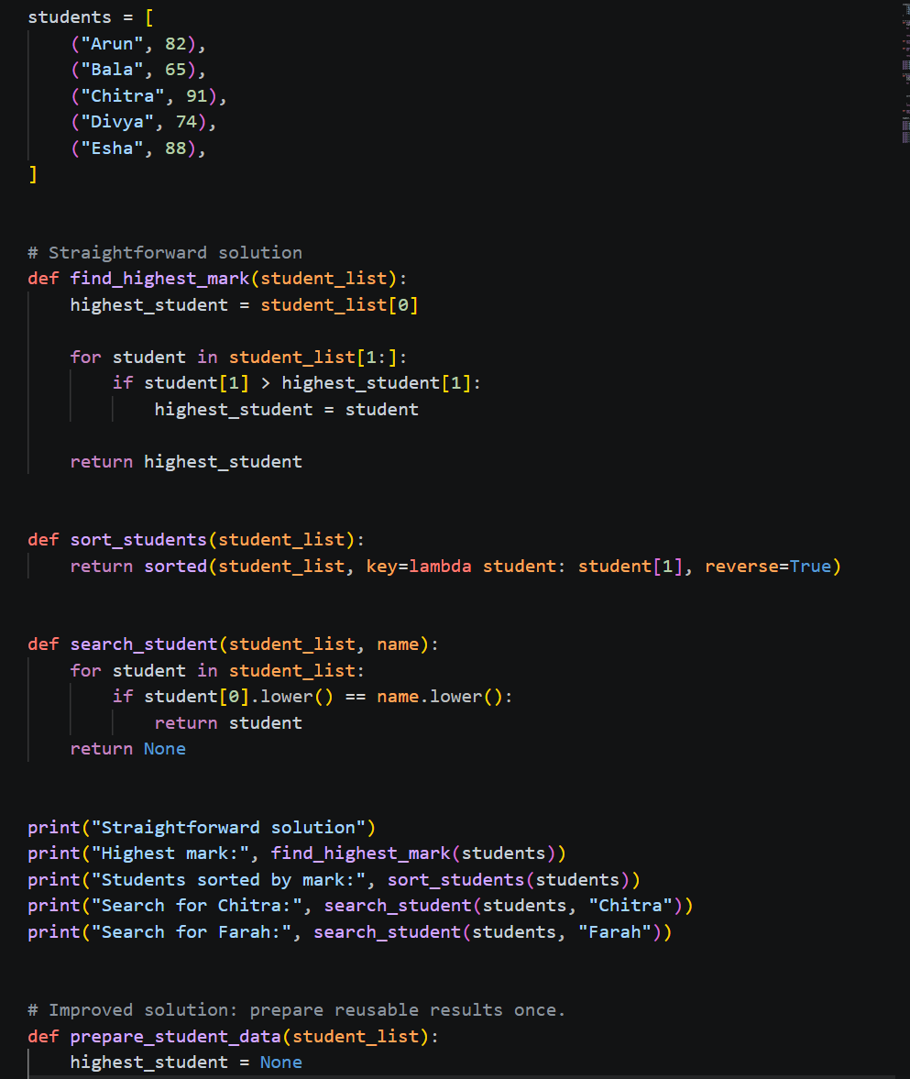

4.OUTPUT:
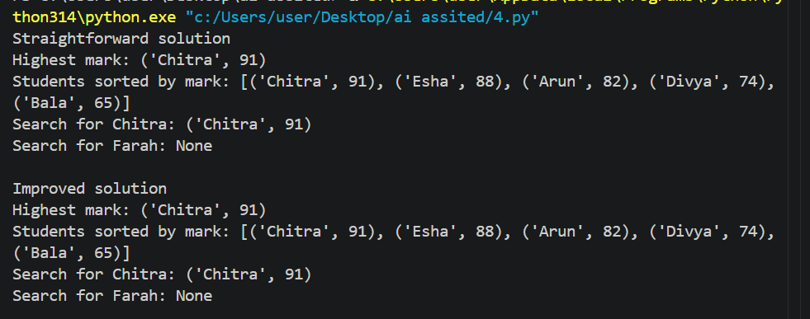

5.OBSERVATION:
the program finds the highest mark, sorts students, and searches by name efficiently.

Question 5:
Q5 – Optimisation Challenge: Best Combination
Problem / Starter Code:
items = [
("Laptop", 60000),
("Phone", 30000),
("Tablet", 20000),
("Watch", 10000),
("Headphones", 5000)
]

budget = 50000

# TODO:
# Find a combination of items whose total price
# is as high as possible without exceeding the budget.
Student Tasks:
• Design a solution to maximise total value without exceeding the budget.
• Start with a simple approach and explain it.
• Use AI to compare Brute Force, Greedy and Dynamic Programming.
• Determine which approach guarantees an optimal solution for this formulation.
• Implement the selected solution.
• Test at least three budgets.
• Explain time and space complexity and possible optimisation for larger inputs.

2.PROMPT:
“Find the best combination of items within the ₹50,000 budget. Compare simple, greedy, and dynamic programming methods.”

3.CODE:
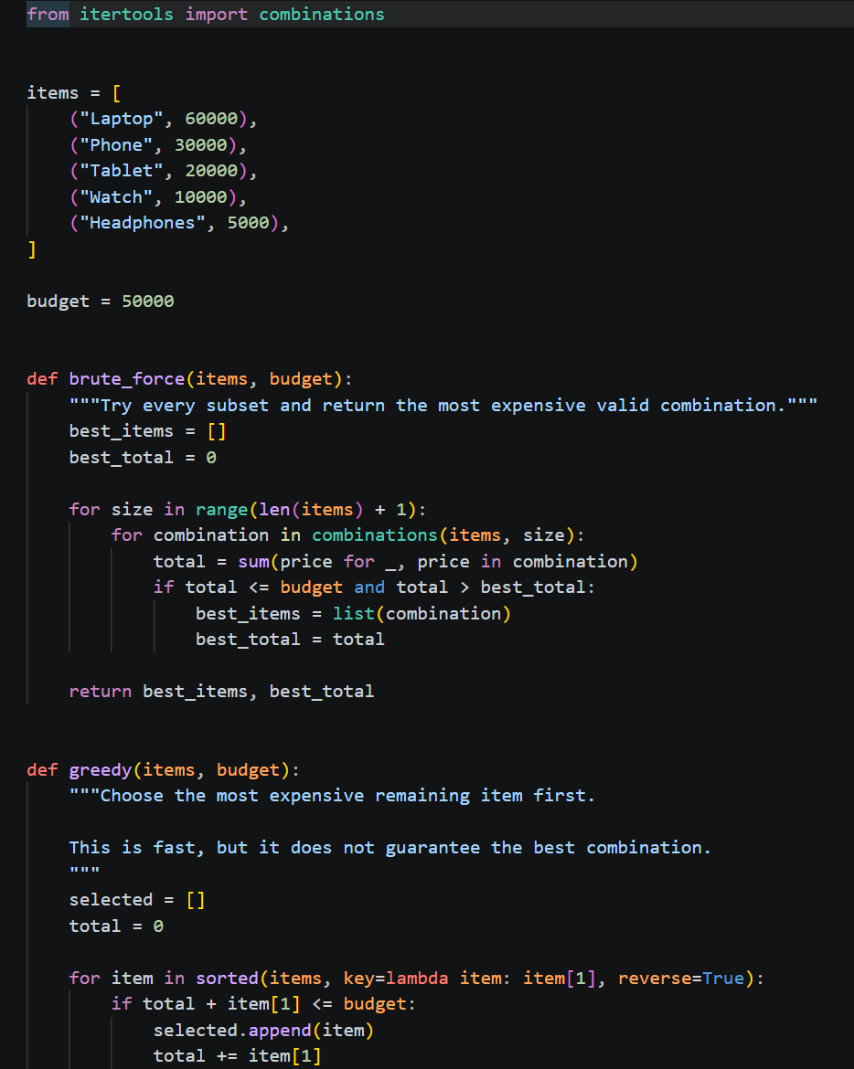

4.OUTPUT:
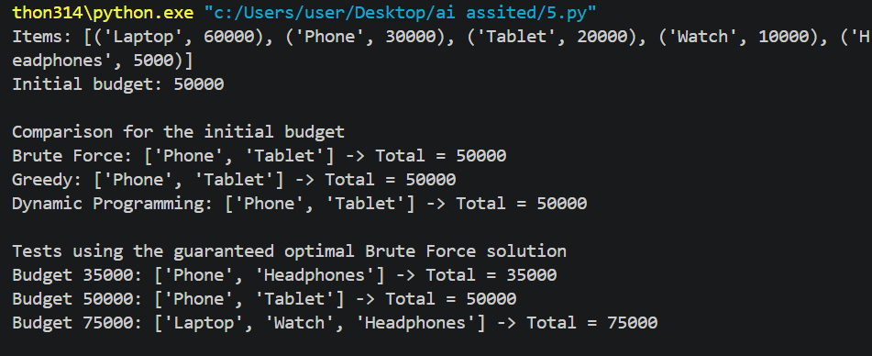

5.OBSERVATION:
The program selects items with the highest possible total price without exceeding the budget.

